

Exercises Report - Lab 6
LAB 6 -Secrets Management using GPG

Course: Cyber Security

Ljubljana, 28/5/2026 Vishnu Viswanath Thattrakkal
Student ID- 35250024

LAB 6 -Secrets Management using GPG

INTRODUCTION
In modern information systems, secrets such as passwords, API keys, authentication tokens, and encryption certificates are essential for securing applications and services. These secrets allow systems to communicate securely and protect sensitive data from unauthorised access.

However, storing secrets directly in source code or public repositories creates serious security risks. If attackers gain access to the codebase, they can easily steal credentials and compromise systems, databases, or cloud services. Many real-world data breaches occur because sensitive information was accidentally exposed in repositories or configuration files.

To reduce these risks, organisations use encryption and secrets management techniques. One common method is GPG (GNU Privacy Guard), which enables secure encryption and decryption of sensitive data. By encrypting files containing secrets, only authorised users with the correct private key can access the information.

This exercise focuses on understanding the importance of protecting secrets, learning why secrets should never be stored in source code, and applying basic security practices using GPG encryption. It also introduces the fundamental concept of Secrets Management without relying on specialised enterprise tools.

Scenario
Scenario

A company is developing an application that communicates with an external API service. To authenticate requests, the application uses an API key provided by the external service provider. Since the API key contains sensitive information, it must be stored securely to prevent unauthorised access and misuse.
The company requires that the API key:

* is stored locally on the system,
* is protected from unauthorised users,
* Can only be accessed by authorised personnel or processes.
To achieve this, encryption techniques and secure handling practices must be implemented. In this exercise, GPG (GNU Privacy Guard) is used to encrypt and manage the sensitive API key, demonstrating the basic principles of Secrets Management without specialised tools.

Prepare secrets

Create a file with secrets:
echo "API_KEY=super-secret-key-123
DB_PASSWORD=VeryStrongPassword" > secrets.env
echo "API_KEY=super-secret-key-123
DB_PASSWORD=VeryStrongPassword" > secrets.env

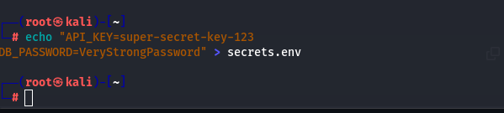
Image -1

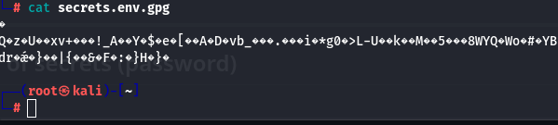
Image - 2

Symmetric encryption of secrets (password)

Encrypt the file with the password:
gpg -c secrets.env

This created an encrypted file: secrets.env.gpg
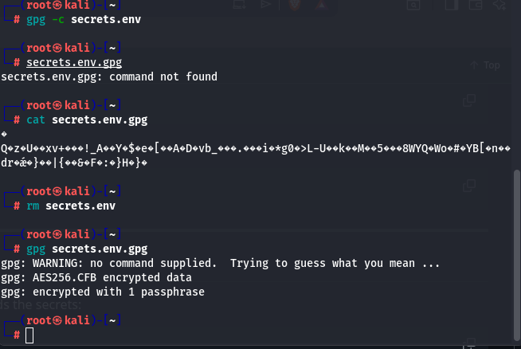
Image -3
After encryption, the original unencrypted file was removed for security purposes.
rm secrets.env

Decrypt the secrets
When an application or administrator needs the secrets:
When an application or administrator needs the secrets:
gpg secrets.env.gpg

The secrets.env file is recreated.
Or we can just print it to the screen:

gpg -d secrets.env.gpg
gpg secrets.env.gpg

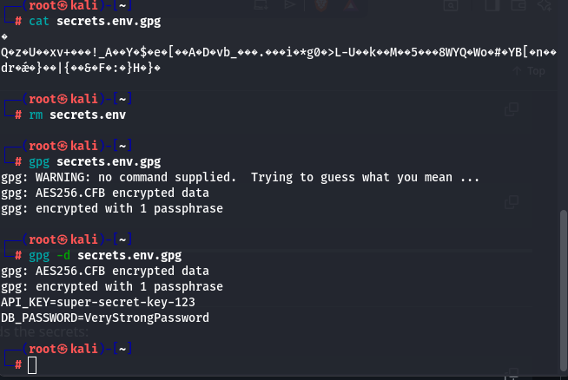
Image -4

Asymmetric encryption

Instead of using a shared password, asymmetric encryption uses a public key to encrypt the file.
- gpg --encrypt --recipient student@example.com secrets.env
- This creates the encrypted file: secrets.env.gpg

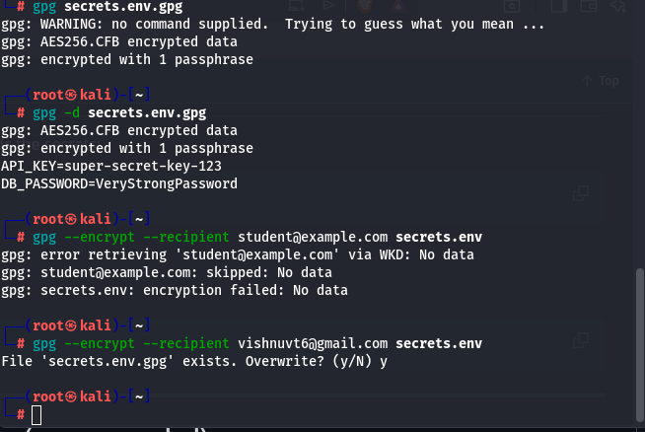
Image -5

Advantages
- No shared password is required
- Only the owner of the private key can decrypt the file
- More secure for professional environments

Using secrets in an application (simulation)

The secrets were loaded into environment variables for temporary use by the application.
- source secrets.env
- echo $API_KEY
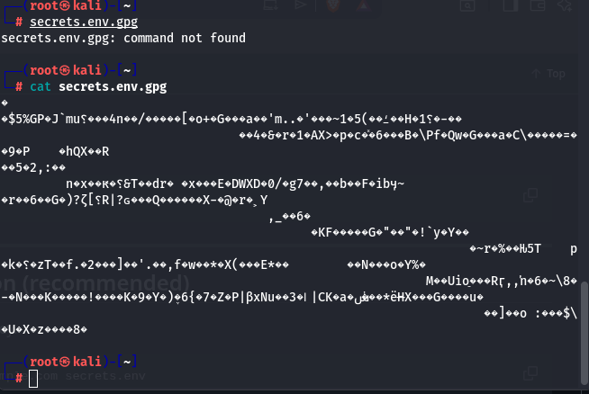
Image -6

After use, the variables were removed from memory for security purposes.

unset API_KEY
unset DB_PASSWORD

Simulating a repository leak
In this simulation, the repository only contains the encrypted file: secrets.env.gpg

An attacker tries to access the file using GPG: gpg secrets.env.gpg

Without the correct password or private key, access to the secrets is not possible.
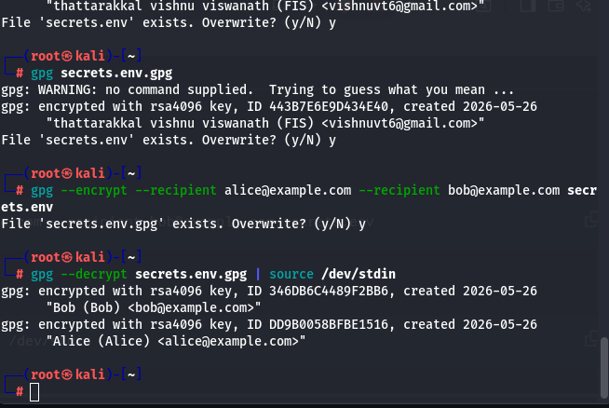
Image 7

Reflection
- Why don't secrets belong in the source code?
Secrets should not be stored in source code because repositories can be leaked, shared accidentally, or accessed by unauthorised users. If API keys or passwords are exposed, attackers may gain access to applications, databases, or cloud services.
What is the difference between symmetric and asymmetric secret encryption?
Symmetric encryption uses one shared password for both encryption and decryption.
Asymmetric encryption uses two keys:
- a public key for encryption,
- a private key for decryption.
Asymmetric encryption is more secure because the private key is never shared.
- What happens if we lose the private key?
If the private key is lost, the encrypted data cannot be decrypted anymore. Access to the secrets is permanently lost unless a backup of the private key exists
- How would you handle this in a larger enterprise?
In a larger enterprise, secrets would be managed using dedicated tools such as HashiCorp Vault, AWS Secrets Manager, or Azure Key Vault. These tools provide centralised storage, access control, secret rotation, monitoring, and secure integration with applications and CI/CD pipelines.

